# QA Fundamentals and Manual Testing Regular Exam



# Part I – TimeWise Web Application

You are provided with a web application, **Time Wise**, along with a specification of the requirements. The primary objective of the exam is to ensure the App functions work as expected according to the provided use cases. This involves **creating test cases for each of the** **USE CASES**. It also includes the **detection and detailed documentation of any identified bugs**. You have to document all your work in the provided **Test Management and Bug Tracker Template**.

## Software Requirements

### 1. Introduction

#### 1.1. Purpose

The objective of this document is to provide a description of the **TimeWise application** (also referred to as **The App**). It will present an overview of the key functionalities.

#### 1.2. Scope

This document includes high-level descriptions of the **basic functionalities of The App**, such as user registration, login, profile editing, task creation and management. It does not cover any special user (Administrator) functionalities.

### 2. Overall Description

#### 2.1. System environment

**TimeWise** can be reached online and is designed for people who want to manage their time better. **The App** is available on the **following url**:

[**http://timewise2-env.eba-mkmm3jwy.eu-north-1.elasticbeanstalk.com/**](http://timewise2-env.eba-mkmm3jwy.eu-north-1.elasticbeanstalk.com/)

#### 2.2. Key Features

##### 2.2.1. Landing page

The Landing Page is **simple and focused** on getting visitors to **Login** or **Register**. The Landing Page is scrollable and includes the following:

**Title and Description:** The Landing Page starts with a title that says "**TIMEWISE**". Below it, there's a text explaining what TimeWise is all about: "TimeWise is a task and schedule management tool that helps you stay organized and on top of your work. With TimeWise, you can easily create and manage tasks, set deadlines, and track your progress."

**"Optimize Your Time Now!" Button**: Upon clicking the button, it leads to the **Register / Login** page, making it easy for new visitors to join and start using TimeWise.

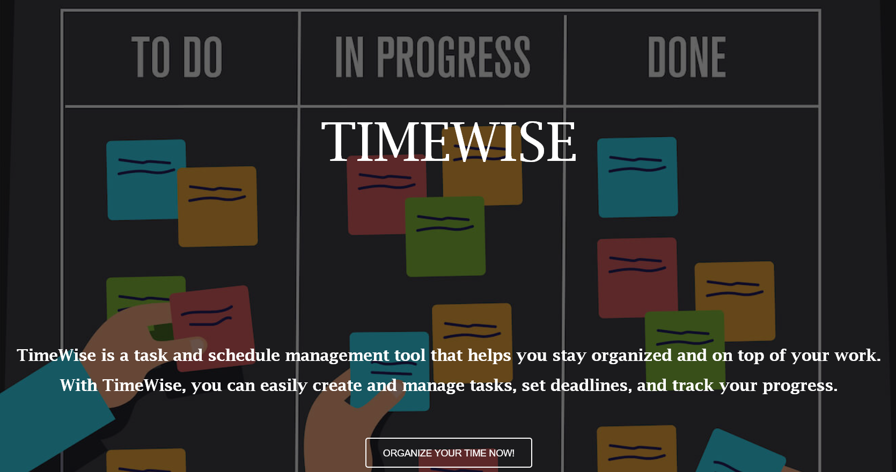

**Inspirational Video Link:** Below, there's a link to a YouTube video titled **"10 Time Management Tips to Boost Your Productivity"**. This video opens in a new tab and offers useful advice for managing time effectively.

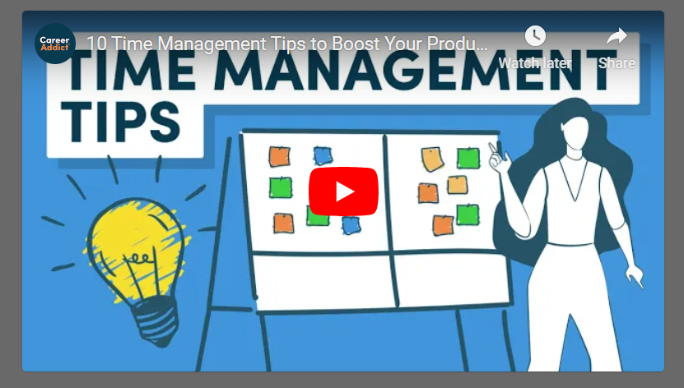

**Footer: Copyright Information**

The footer of the Landing page bears the copyright notice: **"© 2023 Copyright: TimeWise",** indicating the ownership and protection of intellectual property.



**TimeWise part of the text is clickable** and it leads to **Terms of Service page**.

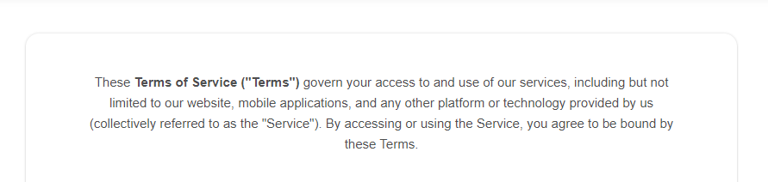

##### 2.2.2. Register / Login Page

**The Register / Login Page** is accessed by clicking on **"Optimize Your Time Now!" Button on the Landing page**. Two buttons are present here **LOGIN** and **REGISTER**, and by clicking them the user is taken to the corresponding functionality.

###### **a. Register**

Upon clicking the **"Optimize Your Time Now!" Button,** by default the Register form is loaded.

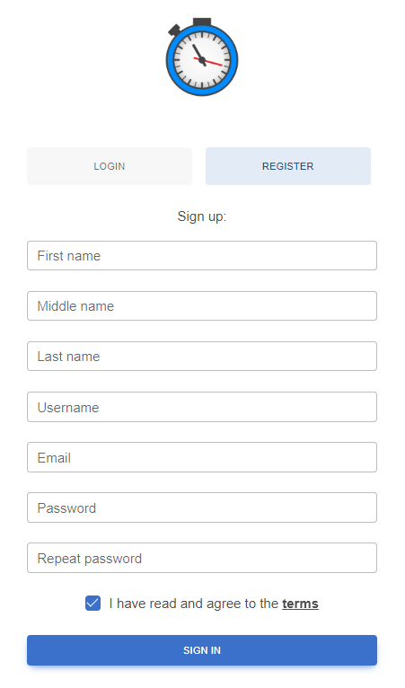

It contains **form fields** for entering the following data: **First name**, **Middle name**, **Last name**, **Username**, **Pasword**, **Repeat password**. The form also includes a checkbox for agreeing to the **Terms of service**, a **hyperlink** leading to the **Terms of service page** (The word "terms" is underlined and clickable) and a **Sign In button** to **submit** the form. The acceptable **requirements for each field are specified** as follows:

**First name:** A 2-40 character field.

**Middle name:** A character field, with max length of 40 characters.

**Last name:** A 2-40 character field.

**Username:** A 3-55 character field. Unique.

**Email:** Requires a valid email, 6-120 characters long. Unique.

**Password:** Any characters are acceptable, with a length of 6-30 characters.

**Repeat Password:** Must match password.

###### **b. Login**

Accessible by clicking the Login button on **The Register / Login Page.**

The Login form provides fields for **Username** or **Email** (either is acceptable) and **Password**, as well as a **Remember me** checkbox and **Forgot password** option, also a **Sign In button**.

**Forgot Password functionality** leads to a **Restore password page**, where the password can be restored by **verified email**.

There are **two options** to **switch** to **Register** form: by the respective **button** and by the **hyperlink** at the bottom.

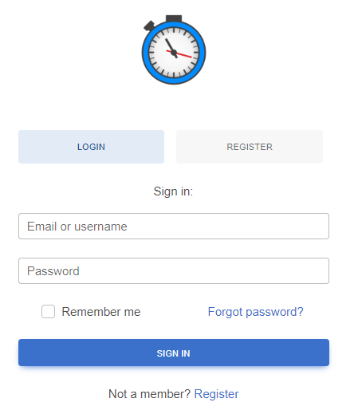

##### 2.2.3. Home Page

When a user logs in, they are taken to the **Home Page.** It contains a navigation bar (also referred to as Navbar) on top, with **TimeWise Home Page link** on the left and **User Profile Icon on the right**. When clicked, **User Profile Icon** reveals a dropdown menu with two options: **My profile** and **Edit**.

The **Sidebar Menu** is another component of the Home Page. It is located on the left, below the **TimeWise Home Page link**. It features the following options:

* **To-Do (+)**
* **In Progress**
* **Done**
* **Logout**

The Home Page of TimeWise is scrollable and designed to enhance productivity by helping users manage their tasks effectively. It features three key sections, each with a motivational phrase, a brief description, and an appropriate picture: **Task Creation & To-Do List**, **Task in Progress** and **Done Your Task.**

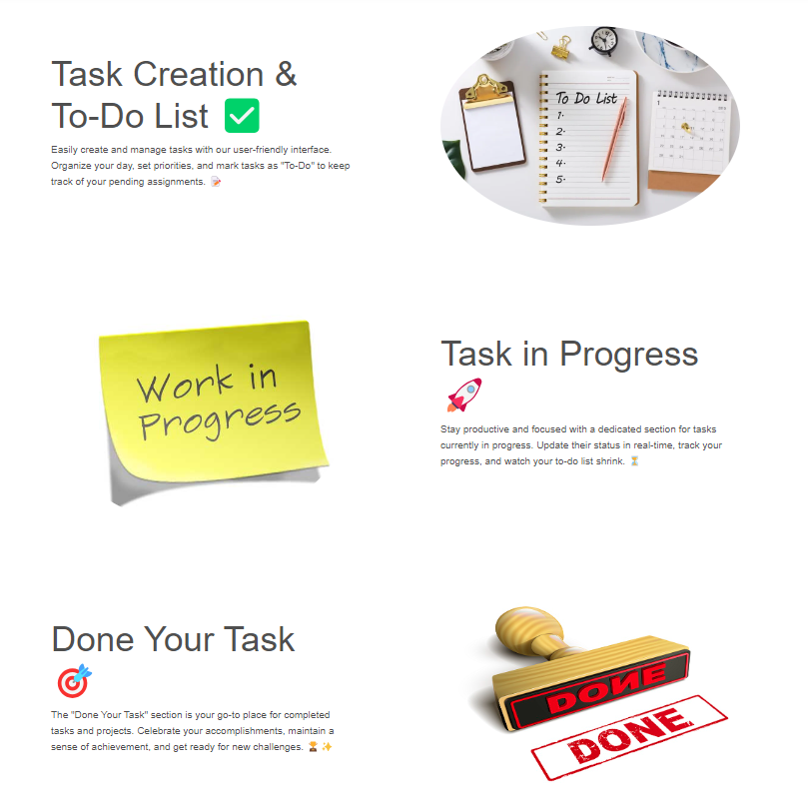





##### 2.2.4. Profile Page

This page is accessible for logged users **from the Navbar, top-right Profile Icon drop-down menu**. This page features a **user's avatar, first name, last name, username, and email**, with options **to link social media accounts**. Users can **edit** their profile via the **blue button** and **view their task counters**—**To-Do, InProgress, and Done**—which start at zero, indicating the beginning of task management activities.

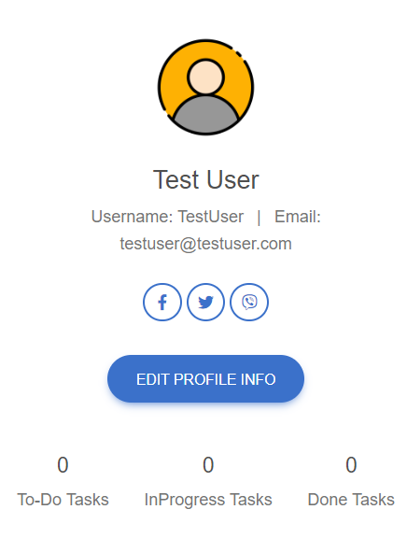

##### 2.2.5. Edit Profile Info Page

Accessible from **Edit Profile Info button** on **Profile page** and **from the Navbar, top-right Profile Icon drop-down menu.** This page allows users to **edit their profile information**, including: **First Name, Middle Name,** and **Last Name.** For the **Avatar Picture**, a **valid URL** must be provided since **direct uploads are not supported** (for example http://......jpg). Changes are submitted with the **"EDIT"** button or discarded by selecting **"CANCEL".**

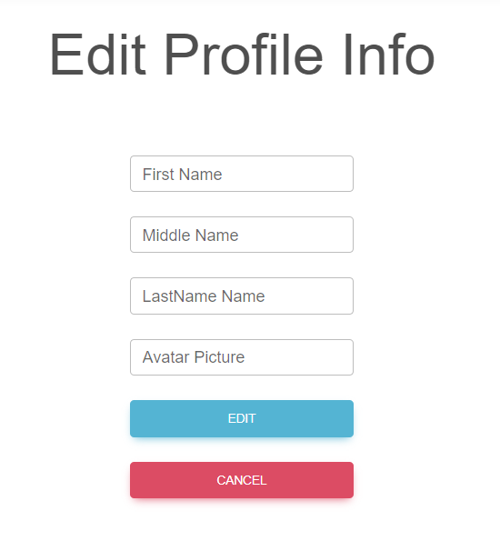

Upon clicking on **EDIT button**, it redirects to My Profile page, where the newly provided information is visible.

##### 2.2.6. То-Do, InProgress and Done boards

All Boards are accessible from the sidebar menu and share the same behaviour: empty by default and when a task is created it goes directly to the corresponding board, depending on it's status.

**The "To-do" page**, has an exeption, since it is the place for creating a new tasks. Users are greeted with a prominent **"CREATE TASK"** button centered in the top of the workspace, inviting them to add new tasks to their list.



##### 2.2.7. Create New Task

Available after clicking **Create Task button on To-Do board** and contains the following: **TaskName** field (min. 5 characters - max. 30 characters length), **Description** field (min. 30 characters - max. 256 characters length), **Start Date field** (must be a valid date), **End Date** field (must be a valid date after the Start Date) , **Select Status** field, **CREATE** and **CANCEL buttons**.

All fields are mandatory and an error message is displayed if not entered correctly, for example:

 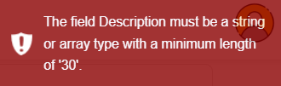

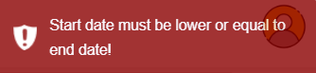 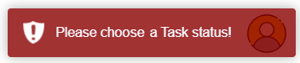

The newly created task is visible on the **corresponding board page**, depending on it status.

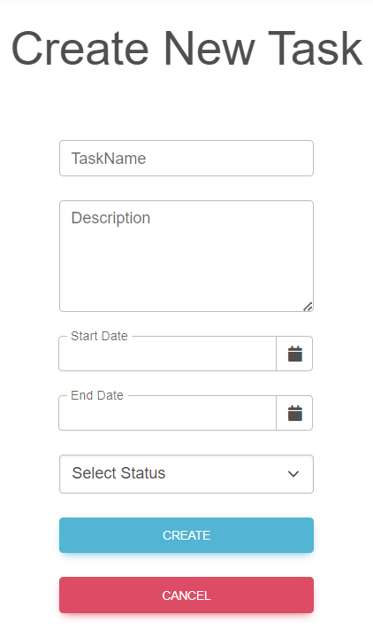

##### 2.2.8. Task View and Edit

Each Task, regardless of its current status board (To-do, In Progress, or Done) appears the same. It includes the following.

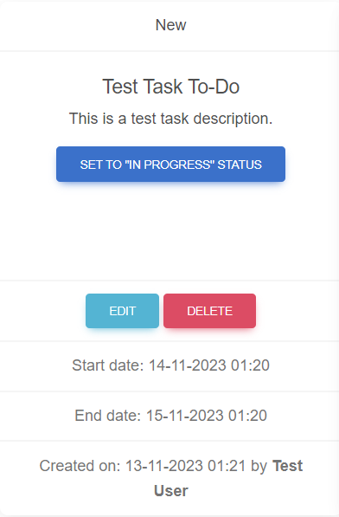

**Status Indicator:** The task card displays a label at the top, indicating its current status which aligns with the board it is located on:

* **"New"** for tasks on the "To-do" board;
* **"In Progress"** for tasks that have been moved to the "In Progress" board;
* **"Done"** for tasks that are on the "Done" board.

The main body of the card shows the task's name and provides a brief summary.

**Action Buttons:** A **Central Button,** such as "SET TO 'IN PROGRESS' STATUS", **allows the user to change the task's status, which will move the task to the corresponding board. The button's label changes depending on the current board.**

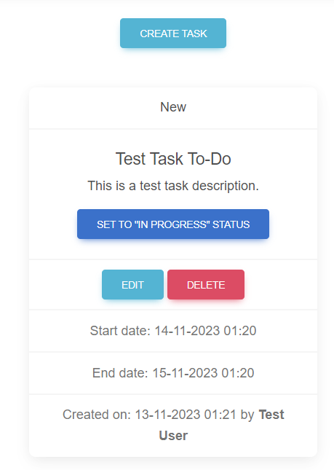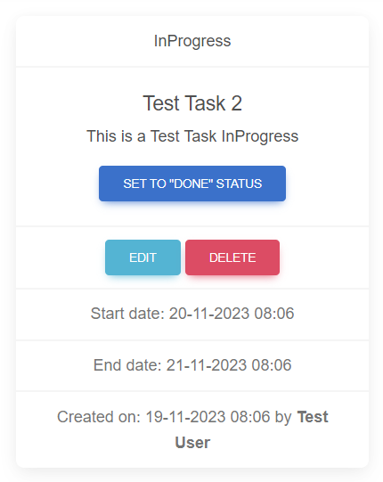 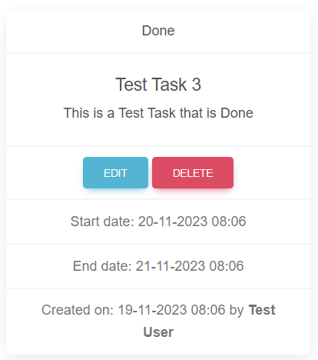

**"EDIT" and "DELETE"** buttons enable the user to modify the task's details or remove the task from the board entirely.

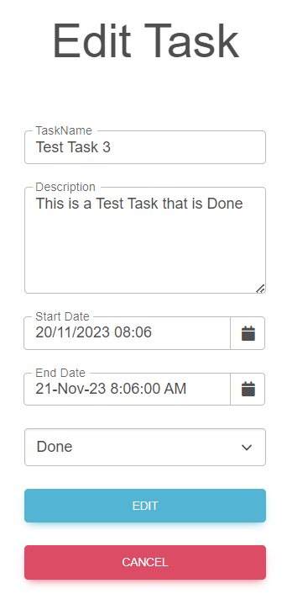 

## Functional Requirements

### Use Case 1 (Landing Page)

Users should be able to access the TimeWise app from its designated URL via the Internet, which should load the Landing Page. The page should display the "Optimize Your Time Now!" button, which directs to the Login/Register page. Optionally, the usershould be able to view the "10 Time Management Tips to Boost Your Productivity" video by clicking the provided link.

### Use Case 2 (User Registration)

From the Registration/Login page visitors should be able to navigate to the Registration form and successfully register. This involves filling out fields for First Name, Middle Name, Last Name, Username, Email, Password, and Repeat Password, along with agreeing to the Terms of Service.

### Use Case 3 (User Login)

From the Registration/Login page visitors should be able to log in using the Login form by entering their Username or Email and Password. The form should also offer a "Remember Me" option and a "Forgot Password" link for password recovery.

### Use Case 4 (Home Page and Navigation)

Logged-in users should arrive at the Home Page, featuring a Navbar with a Home Page link and a User Profile Icon. The Sidebar Menu should provide access to the task boards: "To-Do," "In Progress," and "Done. Users should have the ability to navigate across different sections of the app through the Sidebar Menu and should be able to log out of the app using the "Logout" button.

### Use Case 5 (Profile Management)

Once logged in, users should be able to view and edit their profile information from the Navbar's Profile Icon dropdown menu. This includes updating their First Name, Middle Name, Last Name, and Avatar Picture (via URL).

### Use Case 7 (Task Creation and Management)

Logged-in users should be able to navigate to the "To-do" board and create a new task by clicking the "CREATE TASK" button and entering the required information in the form fields. Upon creation, the task should appear on the appropriate board based on its status.

For any task, users should be able to view detailed information, edit the task's contents, or delete the task. This includes modifying the task's name, description, and start/end dates. Users also should be able to update the status of tasks between the "To-do," "In Progress," and "Done" boards.

## TimeWise Web App Tasks

### **1. Test Cases**

You need to write **test cases** **for each of the 6 Use cases**.  
**Each Use case** should have at **least 2 Test Cases**.

You should write **at least 15 test cases**.

### 2. Bug Reports

You should find and describe at least **5** bugs.

**2 of the bugs** should have **high priority** OR **blocking/critical severity**.

### 3. Template Use the provided Test-Management-and-Bug-Tracking-Template.xlsx to document your work.

# Part II – TimeWise API

This section provides information about the **TimeWise API endpoints** and their functionalities. It serves as a guide to understand how to interact with the TimeWise API. This is the base URL:

[**http://timewise2-env.eba-mkmm3jwy.eu-north-1.elasticbeanstalk.com/api**](http://timewise2-env.eba-mkmm3jwy.eu-north-1.elasticbeanstalk.com/api)

The following endpoints are supported:

### 1. User

* POST /api/User/Register – register a new user: post a JSON object in the request body, e.g.   
  {

"userName": "string",

"firstName": "string",

"midName": "string",

"lastName": "string",

"email": "user@example.com",

"password": "string",

"rePassword": "string"

}

Note: midName is optional.

* POST /api/User/Authorization - log in an existing user (post a JSON object in the request body, e.g.

{

"email": "string",

"password": "string"

}

### Access Token

* When a user logs in, the response format is JSON object, e.g.   
  **{**"email": "user@example.com", **"password": "string", "accessToken": "eyJhbGciOiJ…"}**

**NB! Access token is needed for all Tasks requests. It should be placed under the Authorization tab, Bearer Token option.**

### 2. Task

All of the **following requests require Authorization**.

* **GET /api/Task/AllTasks** – list all tasks (empty request body)
* **GET /api/Task/Count** – list the count of all tasks, and the count of tasks by status ("ToDo", "InProgress", "Done" (empty request body)
* **POST** **/api/Task/Create** – create a new task: post a JSON object in the request body, e.g.   
  **{**

**"taskName": "task",**

**"startDate": "25/01/2023 16:28",**

**"endDate": "26/01/2023 18:28",**

**"description": "Task description has 30 characters",**

**"status": "ToDo"**

**}**

**Note:** **description** must be at least 30 characters; **status** should be one of the following: "ToDo", "InProgress", "Done"

* PUT /api/Task/Edit/taskId – replace the existing task with the new one: post a JSON object in the request body, e.g.

**{**

**"taskName": "changed task",**

**"startDate": "26/01/2023 17:28",**

**"endDate": "27/01/2023 19:28",**

**"description": "This description has been changed.",**

**"status": "InProgress"**

**}**

* DELETE **/api/Task/Delete/taskId** – delete existing task;

## TimeWise API Tasks: Postman Requests

Your task is to write **API requests** with Postman for certain RESTful API endpoints.  **You should organize your requests in a collection.**

### **1. Log in to the API**

**Send a POST request with your email and password**, that you previously created from the Time Wise Web App. If properly executed, you will receive your access token as a part of the response body. Use it as a Bearer Token in the Authorization section for the next requests.

### 2. Create a new task

**Send a POST request with the attributes needed for creating a new task**

Keep in mind that the full attributes in the JSON body are as follows:

**{**

**"taskName": "string",**

**"startDate": "DD/MM/YYYY HH:MM",**

**"endDate": "DD/MM/YYYY HH:MM",**

**"description": "Task description has 30 characters.",**

**"status": "ToDo"**

**}**

### 3. List all tasks

**Send a GET request to receive a list of all tasks**.

This request will return all tasks created through your profile. So, if you created any tasks via the Web App, they also will be listed. In the list of tasks, find the task that you just created. You will **need its id** for the next request.

### 4. Change the the task you created

**Send a PUT request with the attributes needed to replace the task you created in 2. Create a new task.**

### 5. Delete Task

**Send a DELETE request with the attributes needed for deleting the task you just edited.**

# How to submit your work

**1. Create a .zip or .rar archive containing the following:**

- Test-Management-and-Bug-Tracker.xlsx file with your work;

- JSON file containing your collection of requests, created via Postman.

**2. Upload your archive on the SoftUni website, into Regular Exam section.   
Note: It's the same as uploading your homework.**